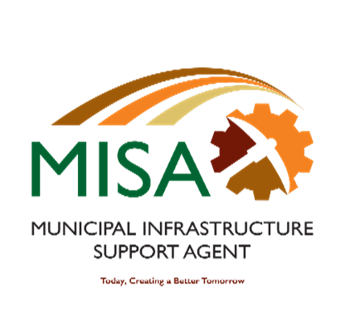

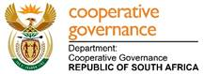

Letaba House, Riverside Office Park, 1303 Heuwel Avenue, Centurion, 0046

Private Bag X105, Centurion, 0046 Tel: 012-848 5300

**IMMEDIATE RELEASE 7 November 2024**

**MISA CEO PARTICIPATES IN THE BUILT ENVIRONMENT CLIMATE CHANGE INDABA 2024**

The Chief Executive Officer of the Municipal Infrastructure Support Agent (MISA), Ms Mapatane Kgomo, has today, 07 November 2024, participated in a panel discussion titled “Equipping Youth with the Necessary Training to Combat Climate Change (Green Leaders of the Future)” During the climate change Indaba which was organised by the Council for the Built Environment (CBE) in KwaSithebe a location in Mandeni, KwaZulu Natal.

The two-day event is centered around creating a climate resilient Built Environment for South Africa while acknowledging and incorporating the Indigenous Knowledge Systems (IKS) in the entire construction lifecycle, process and legislation of both provincial and national government.

During her presentation which was intended to answer the question “why is it necessary to involve youth in combating climate change?” Ms. Kgomo, opened by saying that the inclement weather challenges experienced in the country present an opportunity to get more young people involved in expanding the current scope of infrastructure and service delivery. She further outlined that MISA has taken the approach of equipping the youth through capacity-building programmes and enhancing risk knowledge to build resilience and reduce disasters through exposing young graduates to various areas of knowledge. Through such investments in our youth, we believe that youth can become innovators of tomorrow and will be able to play an advocacy role in the future when it comes to issues of climate change.

The presentation also stated that MISA equips youth through offering built environment bursaries, apprentices, experiential learnership programme, process controller training, and employing young graduates amongst other programmes. She also alluded that MISA is in the process of establishing a Design Office in partnership with the UJ. This is aimed at equipping the young engineers with the capability to design infrastructure on behalf of municipalities using the latest technologies, including climate resilient approaches in various disciplines.

The theme of the indaba is in line with the long-term strategic goals for MISA which puts emphasis on the Sustainable Development Goals (SDGs) through alignment of the NDP and the African agenda.

For media inquiries, kindly contact:

Ms. Refilwe Mathabathe: 060 500 0951

Ends

Issued by the Municipal Infrastructure Support Agent (MISA)