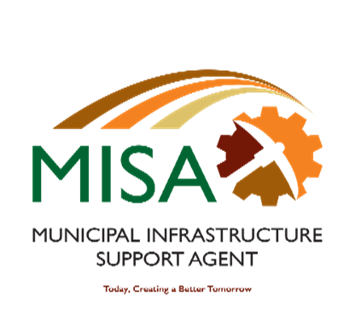

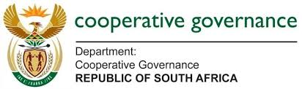

Letaba House, Riverside Office Park, 1303 Heuwel Avenue, Centurion, 0046

Private Bag X105, Centurion, 0046 Tel: 012-848 5300

**Register of received bids: Bid no. MISA/IDMS/SDF/046/2021/22**

|  |  |  |  |
| --- | --- | --- | --- |
| **No** | **Name of Bidder** | **Bid Price** | **BBBEE Level (To be verified)** |
| **No** | **Name of Bidder** | **Bid Price** | **1** |
| **1** | SMEC SOUTH AFRICA PTY LTD | R 2 730 490.07 | 1 |
| **2** | ASIKA CONSULTING | R 5 408 841.00 | 2 |
| **3** | ILUNGELO LAMI TRADING CC | R 1 775 000.00 | 1 |
| **4** | TJDYNAMIC DEVELOPMENT PRACTICES | R 9 66.000 | 1 |
| **5** | TSHANI CONSULTING | R 34 87 260.00 | 1 |
| **6** | NTG SOLUTIONS CC | R 4 244 880.00 | 1 |
| **7** | ZUTARI PTY LTD | R 3 407 653.87 | 1 |
| **8** | PFUKANI -KUSILE CONSULTING CC | R 4 715 000.00 | 1 |
| **9** | DITSAMAI INVESTMENTS & PROJECTS CC | R 4 762 863.00 | 1 |
| **10** | CADRE CONNECT PTY LTD | R 2 522 943.60 |  |
| **11** | DEVELOPMENT PLANNERS JV | R 8 171 900.00 | 1 |