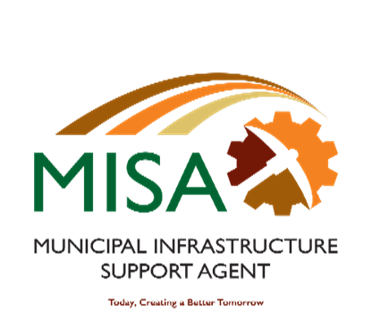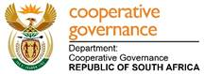

**MUNICIPAL INFRASTRUCTURE SUPPORT AGENT**

Letaba House, Riverside Office Park, 1303 Heuwel Avenue, Centurion, 0046

Private Bag X105, Centurion, 0046 Tel: 012-848 5300

**MISA TECHNICAL BURSARY SCHEME APPLICATIONS FOR 2022 ACADEMIC YEAR**

The Municipal Infrastructure Support Agent (MISA) is a government component, accountable to the Minister of Cooperative Governance and Traditional Affairs (Cogta), established in terms of Section 7(s) (c) Schedule 3 of the Public Service Act of 1994 (as amended). One of the primary functions of MISA is to contribute towards building the technical capacity of municipalities to undertake efficient infrastructure planning, delivery, operations and maintenance. MISA strives for excellence in developing a pipeline of Built Environment professionals in Local Government and is hereby inviting applications for bursaries from interested individuals who wish to undertake undergraduate academic studies in the following fields:

|  |  |
| --- | --- |
| NUMBER | Required Study field: Technical and Vocational Education and Training Colleges |
| 1. | Civil Engineering |
| 2. | Electrical Engineering |

Whilst the opportunity is not exclusively limited to individuals from previously disadvantaged communities, MISA will give preference to qualifying candidates from rural areas as well as households with a combined total annual household income of less than R600 000. MISA is an equal opportunity employer, therefore, people with disability, youth from previously disadvantaged are encouraged to apply.

**Eligibility Criteria:**

* Certified copy of Identity Document.
* South African youth with relevant entry requirement from the above-mentioned study fields aspiring to study in any South African Institution of Higher Learning, i.e. TVET College.
* Proof of your registration with a TVET college
* Total annual household income of less than R600 000 (submit affidavit by parent(s) or guardian (s) and or proof of parents’ income (payslips) or Affidavit of unemployed parents.
* Acceptance for admission by a South African Institution of Higher Learning (TVET College) for the 2022 academic year (submit proof of registration).
* Your financial record/statement of your account by your **institution of higher learning (TVET college).**

**Enquiries**: Application forms may be downloaded from [www.misa.gov.za](http://www.misa.gov.za) / www.cogta.gov.za or may be requested via email at [TS.bursaries2022@misa.gov.za](mailto:TS.bursaries2022@misa.gov.za)

**KINDLY NOTE THAT DUE TO A HIGH NUMBER OF APPLICATIONS, ONLY SUCCESSFUL CANDIDATES WILL BE CONTACTED**

**For Enquiries contact Ms Nobuhle Latha 012 848 5529 or Ms Thulisile Mosoeu on 012 848 5562**

*All applications together with relevant documents must be submitted at* [*Ts.bursaries2022@misa.gov.za*](mailto:Ts.bursaries2022@misa.gov.za) *quoting the relevant reference number and required study field for the attention of* ***Ms. Nobuhle Latha*** *or* ***Ms. Thulisile Mosoeu.***

**The closing date for submission of applications is the 19th of August 2022. Failure to submit the required documents will result in the applications not being considered.**

**No faxed, hand delivered or postal applications will be considered. **