 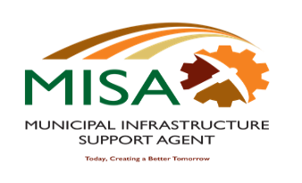

**.**

**MUNICIPAL INFRASTRUCTURE SUPPORT AGENT**

Letaba House, Riverside Office Park, 1303 Heuwel Avenue, Centurion, 0046

Private Bag X105, Centurion, 0046 Tel: 012-848 5300

**Form 1 TS: Trade /Discipline Email addresses**

1. **APPLICATIONS FOR APPRENTICESHIP PROGRAMME WITH REQUIRED DOCUMENTATION SHOULD BE EMAILED TO THE FOLLOWING ADDRESS:**

|  |  |
| --- | --- |
| **APPRENTICESHIP PROGRAMME** | |
| Electrical: ( REF NO:09/2021/01) | TSElec202101@misa.gov.za |
| Plumbing :( REF NO:09/2021/02) | TSPlum202102@misa.gov.za |
| Bricklaying: (REF NO:09/2021/03) | TSBrick202103@misa.gov.za |
| Motor mechanic:( REF NO:09/2021/04) | TSMotorm202104@misa.gov.za |
| Diesel mechanic :( REF NO:09/2019/05) | TSDieselm202105@misa.gov.za |

1. **APPLICATIONS FOR EXPERIENTIAL LEARNESHIP PROGRAMME WITH REQUIRED DOCUMENTATION SHOULD BE EMAILED TO THE FOLLOWING ADDRESS:**

|  |  |
| --- | --- |
| **EXPERIENTIAL LEARNERSHIP PROGRAMME** | |
| Electrical: ( REF NO:02/2021a) | TSElec2021a@misa.gov.za |
| Civil :( REF NO: 02/2021b) | TSciv2021b@misa.gov.za |