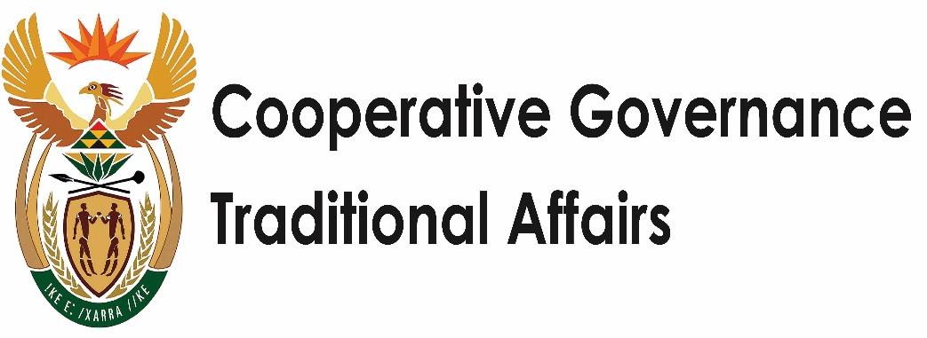

**COLLOQUIUM**

**Zero Based and Gender Responsive Budgeting**

**DR NKOSAZANA DLAMINI ZUMA, MP,**

Minister of Cooperative Governance and Traditional Affairs;

**30 JULY 2020**

Programme Director Deputy Minister Bapela;

Mr Tito Mboweni - Minister of Finance;

Prof Edgar Pieterse – Research chair in urban policy and Director of African Centre for Cities;

DM Tau and our condolences for the bereavement which has visited upon your family;

Dr Jia Yu – Director of the Department of International Development Cooperation – Perking University;

Ms Silvia Ntambi – Chairperson of the Uganda Equality Commission;

Ms Roberta Clarke – Regional Director; East and Southern Africa – UN Women;

Ms Katherine Gifford – Policy Specialist: Governance and National Planning – UN Women;

Ms Sara O’Rourke – Associate Partner, McKinsey and Company;

Dr Oyodela Odusola – District Development Officer, UNDP;

Dr Michael Sutcliffe;

Mr Trevor Fowler;

Directors General of DCOG and DTA;

CEO of MISA;

Colleagues from the women’s and COGTA departments;

Ladies and Gentlemen.

We are ever grateful that you have made time, at short notice, to assist us in thinking through ways in which we can effectively utilise our budget in addressing poverty, unemployment and inequality in our society. That we meet a day after we laid to rest Bab’ Andrew Mlangeni, our struggle hero and the last of the last Rivonia trialists, should serve as a call to action. Bab Mlangeni represented a generation of selfless leaders who were committed to securing the political and economic liberation of the oppressed masses.

In the South African context, political freedom has largely been attained with us having peaceful and periodic elections with some levels of participation by our citizens. However total economic emancipation has proven to be slightly more evasive with the perennial challenges of poverty, inequality and unemployment.

Even though the poverty rates have gradually reduced reaching about from 53,2% in 2011, they have been on the rise since 2015 reaching, the high rate of 55,5%. The extent to which our economy grows is unable to keep apace, with the levels of poverty.

It is the same with unemployment which is edging closer and closer to the 30% mark with the impact of COVID some predictions placing it at 50% in the medium term, unless some drastic action is taken.

Despite an abundance of wealth, natural resources and human resources, South Africa remains one of the most unequal society in the world. South Africa is also a microcosm of the African Paradox of a rich Africa but poor Africans. This is true whether one considers income, wealth, or opportunities inequality. Despite having enough to feed our people a significant number of them remain in hunger. Intergenerational mobility is relatively low and serves as a barrier to inequality reduction.

In our context poverty, inequality and unemployment, are largely dependent on gender, race and class. 52% of females are poor and 74,8% of female headed households in rural areas are poor. This is further compounded by inherited apartheid ownership patterns. For instance, the latest land audit shows that whites own 72% of total farm and agricultural holdings, coloureds own 15%, Indians own 5% and Africans 4%. The same audit shows that women despite being the majority in rural South Africa own only 13% of farms and agricultural land, while men own 71%. Apartheid spatial planning patterns also have the majority living further from places of work with limited and relatively expensive transport and communications infrastructure.

It is therefore clear to us that in order to address these triple challenges of poverty, inequality and unemployment, we must direct our resources where they are most needed. This also implies that we must address gender equality and equity. For far too long our national budgets have been gender blind and not paying attention to the different roles, capabilities, needs, responsibilities and priorities of men and women.

Our programmes and budgets pay little regard to women’s contribution especially in the important areas of unpaid work, which include homeworking, care activities and voluntary and civic work. According to the IMF these can constitute between 10 and 60% of GDP, depending on the country.[1] For instance in Norway the male/female gap in unpaid work is lower with women doing 3.7 hours of unpaid work per day while men do three hours. Whereas in Egypt women do 5,4 hours whilst men only do 35 minutes. This gender gap in unpaid work is not just unfair. It is clearly inefficient.

Therefore, Gender Responsive Budgeting expert Diane Elson advocates that such activities need to be included in the budget as their exclusion leads to “*further discrimination against women, and impaired economic efficiency. We need to change the way that we look at the relationship between different areas of economic life – such as the public and private sectors, the domestic, and the formal and informal*”.[2]

Additionally, we must consider that when income is placed in the hands of women, research shows that they spend 70% of it on the family. As opposed to men who spend only 30% of their income on families. This means that our objective of building resilient, vibrant, sustainable and climate smart communities can best be met by empowering women.

By drawing on the experiences of the experts we have gathered here today we hope to further our case for gender responsive budgeting. Our thesis is not just that it is the right thing to do, but the world over has many examples of the success of women led and inclusive countries and companies, which are more likely to perform better. Besides we cannot hope to build a winning nation when half team is not playing.

There therefore has to be an explicit intent with the requisite institutional capacities and capabilities for gender-responsive fiscal policy. We must recognizes the need for explicit gender budget statements and audits. I often use the example of former Minister of Finance Ngozi Okonjo-Iweala of Nigeria, who used the budgets target of at least 30% of the fiscus towards women, to reward departments that reach this goal.

The departments of Health, Agriculture, Public Works, Communications and Technology, and Water Resources were further singled out, given the impact of these specific ones have on women’s lives.

**Minister Mboweni**, in Rwanda, Uganda, Ethiopia and Tanzania, there are specific directives in relation to gender-budgeting and auditing. These have been complemented by training in the public, private and civil society sectors in countries such as India.

It is therefore our hope that come the end of this colloquium, we will have a better understanding of Gender Responsive Budgeting.

We are also certain that we cannot hope to achieve different results from doing the same thing. Thus, in seeking to have a more gender responsive budgeting framework, we welcome the announcement of the Minister of Finance to utilise the Zero Based Budgeting Framework. It is our firm belief that the framework holds the possibility for us to better target our budgets. Through this framework we can pursue the most impactful actions where the quality of life of our people can be changed.

This is in sync with the District Development Model, which calls on our coordination role as an important part of the activist developmental state. We must be the catalyst of development at all levels and spheres of government. But in order to be that, we must also ask ourselves if we have the systems, the right people in the right places and who are sufficiently motivated, compassionate, responsive and ethical.

There is much work we have to do in that regard.

We see this colloquium as a foundation by which we can chart a longer term course for our departments and entities. We cannot hope to collaborate with other departments and spheres, if we ourselves are not a good part of the team. We cannot also continue to plan year on year, simply ticking the boxes. The aspirations of our people require planned and deliberate interventions, of at least 25 years which are interspersed by 5 year plans. These aspirations also require that we develop society wide supporting systems and programmes. Thus, it is critical that we build partnerships.

For us this colloquium is a turning point and provides an opportunity for the department to explore new ways. It is our hope that this Zero-based budgeting colloquium will provide for us markers towards building resilient, sustainable, vibrant and climate smart communities.

The programme is structured to delve into number of key topics under a particular theme, in a focused manner. The identified experts who are with is today will assist to put the discussions in context by sharing their experiences and issues in the environment on a particular topic.

Going forward, the discussion today should be able to assist the department’s strategic planning process taking into account a longer term view. It should also enable us to draw real linkages and integration in our programmes, so that one programme is not seen in isolation from another. By interrogating each and every line item, asking its gender, spatial, and outcomes dimensions, we can maximise impact and internal coordination.

We will have to challenge each other to think differently, and apply ourselves beyond the day to day work. We must ensure that every working hour and every action is related to the superordinate objectives of addressing the triple challenges of poverty, inequality and unemployment.

It is our firm belief that this can be addressed through resilient, vibrant, sustainable and climate smart communities. We look forward to hearing from the Minister of Finance and fostering collaboration with the National Treasury towards implementing the Zero Based Budget.

**I thank you**

1. <https://blogs.imf.org/2019/10/15/the-economic-cost-of-devaluing-womens-work/>
2. Elson, D., 1999, 'Gender-neutral, Gender-blind, or Gender-sensitive Budgets? Changing the Conceptual Framework to Include Women's Empowerment and the Economy of Care,' Commonwealth Secretariat, London